Fi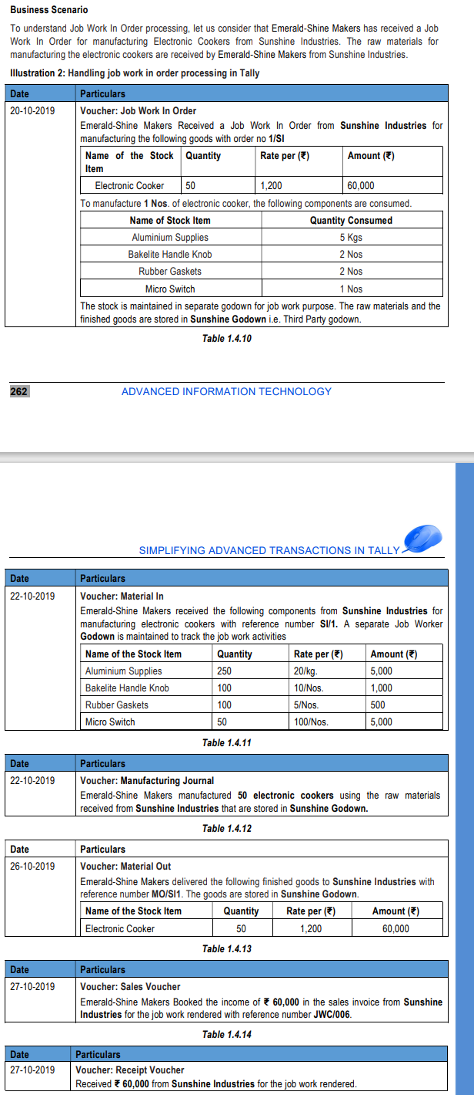

- Create all the Raw material and finished goods items
- Alter the finished goods items set BOM yes and name the process and specify the requirement like to produce 1 electronic cooker you need
          - Aluminum Supplies 5 kg
          - Baketile handle knob 2 Num
          - Rubber Gasket 2
          - Micro switch 2
- Create one voucher type named manufacturing journal under stock journal set use as manufacturing journal yes
- Pass the job work in order
- Create the material in for job work voucher under material in and set use for job work in yes
- Pass the material in for job work against the order which we received from sunshine
- Pass the manufacturing journal to generate the 50 electronic cokers
- Create the material out for job work in and set use for job work in yes
- Pass the material out for job work in and send the electronic cooker to the sunshine traders
- Book the income
- Received income

